**cat command:**

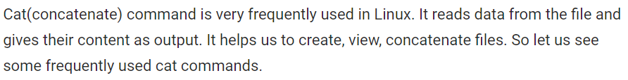

To view the content of a single file

* **cat [file name]**

To view the content of multiple files

* **cat file1 file2**

To view contents of a file preceding with line numbers.

* **cat -n filename**

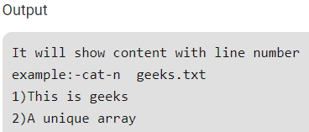

Create a new file named newfile

* **cat >newfile**

Copy the contents of one file to another file.

* **cat [filename-whose-contents-is-to-be-copied] > [destination-filename]**
* **cat file1 >file2**

Cat command can append the contents of one file to the end of another file.

* **cat file1 >> file2**

Cat command can display content in reverse order using tac command.

* **tac filename**

Cat command can highlight the end of line.

* **cat -E "filename"**

If file having large number of contents that won’t fit in output terminal and screen scrolls up very fast, we can use parameters more and less with cat command as show above.

* **cat song.txt | more**
* **cat song.txt | less**

Display $ at the End of File

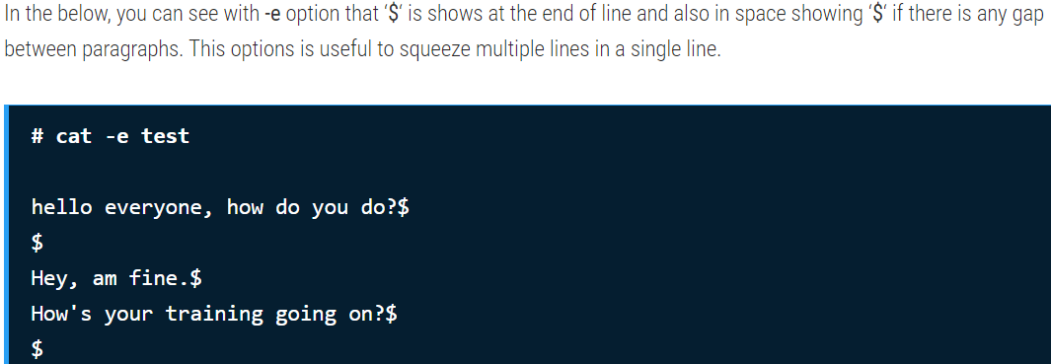

Display Multiple Files at Once

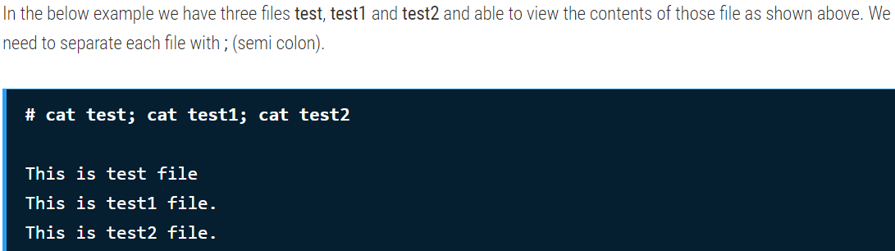

Redirecting Multiple Files Contain in a Single File

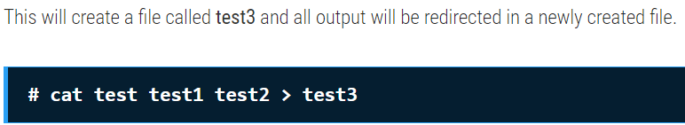

To filter anything from a file using cat command

* **cat [file name] | grep [key word]**
* **cat sonar-elk.yaml | volumeMounts**
* **cat sonar-elk.yaml | ‘volume Mounts’** 🡪use single quotes if there is a space in key word

**touch command:**

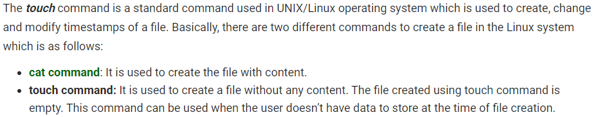

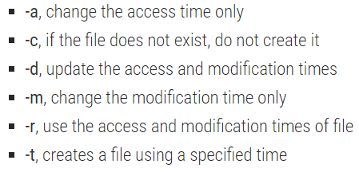

You can create a single file at a time using touch command.

* **Touch file_name**

Touch command can be used to create the multiple numbers of files at the same time. These files would be empty while creation.

* **touch File1_name File2_name File3_name**

This command is used to change access time only. To change or update the last access or modification times of a file touch -a command is used.

* **touch -a fileName**

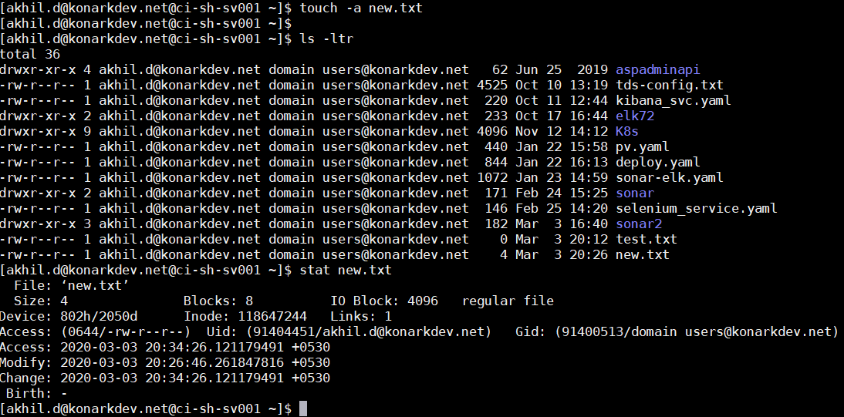

Using -c option with touch command avoids creating new files. For example, the following command will not create a file called leena if it does not exist .

* **touch -c leena**

If you like to change the only modification time of a file called leena, then use the -m option with touch command. Please note it will only update the last modification times (not the access times) of the file.

* **touch -m leena**

This is used to update access and modification time.

* **touch -c-d filename**

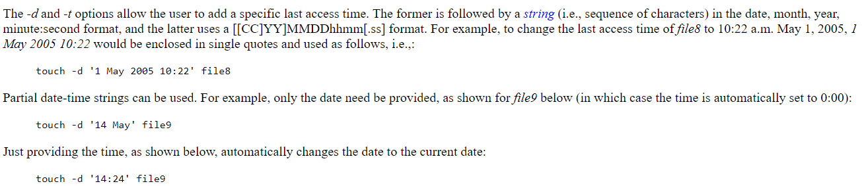

The following touch command with -r option, will update the time-stamp of file meena with the time-stamp of leena file. So, both the file holds the same time stamp.

* **touch -r leena meena**

If you would like to create a file with specified time other than the current time, then the format should be.

* **touch -t YYMMDDHHMM filename**

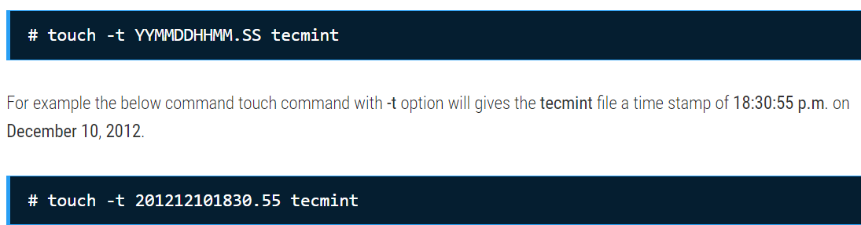

Explicitly Set the Access and Modification times

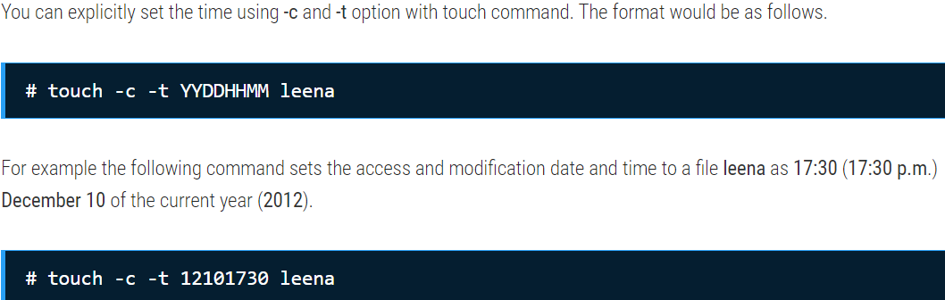

**We can check all these acces, modification etc changes using stat command**